Multiples and factors
What are multiples?
‘The product obtained on multiplying two or more whole numbers is called a multiple of that number or the numbers being multiplied.’
We know about the whole numbers: ‘the numbers starting from 0 and having the pattern 0, 1, 2, 3, 4, 5, up to infinity, are called whole numbers.
The whole numbers minus 0 are the natural numbers.
All the natural numbers are multiples of 1.
There is no end to multiples of any number. The first ten multiples of the numbers starting from 1 to 10 are given here.
First ten Multiples of the Numbers
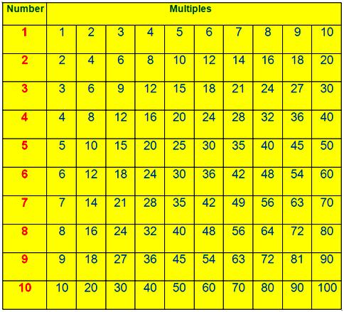

Properties of Multiples
The properties of multiples are discussed step-by-step according to its property.

Property (1):
Every number is a multiple of 1.
As: 7 x 1 = 7,
9 x 1 = 9,
15 x 1 = 15,
40 x 1 = 40

Property (2):
Every number is the multiple of itself.
As: 1 x 7 = 7,
1 x 21 = 21,
1 x 105 = 105,
1 x 212 = 212

Property (3):
Zero (0) is a multiple of every number.
As: 0 x 9 = 0,
0 x 11 = 0,
0 x 57 = 0,
0 x 275 = 0
Property (4):
Every multiple except zero is either equal to or greater than any of its factors.
As, multiple of 7 = 7, 14, 28, 35, 77, …………., etc.
Property (5):
The product of two or more factors is the multiple of each factor.
As: 3 x 7 = 21,
So, 21 is the multiple of both 3 and 7.
30 = 2 x 3 x 5,
So, 30 is the multiple of 2, 3 and 5.
Property (6):
There is no end to multiples of a number.
As: 5, 10, 15, 20, 25, …………….., 100, 105, 110, …………………., are the multiples of 5.
These are the properties of multiples.

Examples on Multiples
Examples on multiples on different types of questions on multiples are discussed here step-by-step.

1. Write the first three multiples of 11.
Solution:
The first three multiples of 11 are:
11 x 1 = 11,
11 x 2 = 22,
11 x 3 = 33,
Thus, the first three multiples of 11 are 11, 22 and 33.
2. Write the first five multiples of 17.
Solution:
The first five multiples of 17 are:
17 x 1 = 17,
17 x 2 = 34,
17 x 3 = 51,
17 x 4 = 68,
17 x 5 = 85
Thus, the first five multiples of 17 are 17, 34, 51, 68 and 85.

Factors
Factors of a number are discussed here so that students can understand the factors of the product.

What are factors?
We know that the product of 3 and 5 is 15.
3 × 5 = 15. Here, 3 and 5 which exactly divide the number 15.
15 ÷ 3 = 5, 15 ÷ 5 = 3. So, 3 and 5 are called the factors of 15.
Consider another example.
1 × 15 = 15.
1 and 15 also divide 15 exactly. (15 ÷ 1 = 15, 15 ÷ 15 = 1)
So, 1 and 15 are also the factors of 15.
Similarly, 7 × 5 = 35 here, 7 and 5 are the factors of 35.
4 × 8 = 32 here, 4 and 8 are the factors of 32.
We can find several other factors of 32 like, 2 × 16 = 32, 1 × 32 = 32
So, 1, 2, 4, 8, 16 and 32 are the factors of 32. Since they all divide 32 exactly.

When a number divides the other number exactly, the former is called the factor of the later.
We can define factor in the following way also.
When a divisor divides the dividend exactly, the divisor is called a factor of the dividend.
We can find the factors of a number as follows.

Find the factors of 24.
24 = 1 × 24
24 = 1 × 24
24 = 1 × 24
24 = 1 × 24
Thus, the factors of 24 are 1, 2, 3, 4, 6, 8, 12 and 24.
Remember,
(i) If a dividend, when divided by a divisor, is divided completely then we name the divisor as the factor of the dividend or multiple.
(ii) If two or more numbers are multiplied to get the product, then each of the numbers is known as a factor of the product.
(iii) A number can be formed by multiplying two or more numbers together. The numbers that are multiplied together are called the factors of the number.
(iv) In all the numbers we have a common factor that is 1 since, 1 multiplied by any number the result is always that number. If any number is divided by that same number then we get the result as 1.

Common Factors
To find the common factors of two or more numbers we will first make a list of the factors of each number.
How to find the common factors of 12 and 18?
Factor of 12  1 × 12 = 12  2 × 6 = 12  3 × 4 = 12 | Factors of 18  1 × 18 = 18  2 × 9 = 18  3 × 6 = 18
Common factors of 12 and 18 are 1, 2, 3 and 6.
How to find the common factors of 6, 8, 10?
Factor of 6 Factor of 8 Factor of 10
1 × 6 = 6 1 × 8 = 8 1 × 10 = 10
2 × 3 = 6 2 × 4 = 8 2 × 5 = 10
Common factors of 6, 8 and 10 are 1 and 2.

Properties of Factors
The properties of factors are discussed step by step according to its property.
Property (1):
Every whole number is the product of 1 and itself so
(i) Each number is a factor of itself.
19 x 1 = 19,
So, 19 is the factor of 19.
(ii) 1 is the factor of every number.
31 x 1 = 31,
So, 1 is the factor of 31.
Property (2):
Every number is a factor of zero (0)
As, 7 x 0 = 0,
17 x 0 = 0,
93 x 0 = 0
So, 7, 17, 93, ……, etc., are the factors of 0.
Property (3):
1 is the smallest factor of a multiple and the greatest factor of a multiple is the multiple itself.
Property (4):
Every number other than 1 has at least two factors, namely the number itself and 1.
Therefore, the properties of factors are explained above so, that student can understand each property.

Examples on Factors

Examples on factors on different types of questions on factors are discussed here step-by-step.
1. Find all the factors of 42.
Solution:
According to properties of factors, 1 and 42 are the factors of 42.
Now we find the numbers which completely divide 42.
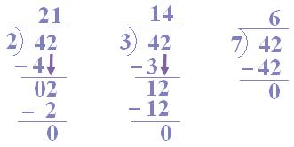
Thus, 1, 2, 3, 7 are complete dividers.
2 x 3 = 6; 3 x 7 = 21; 2 x 7 = 14; are also divisors.
Hence, 1, 2, 3, 6, 7, 14, 21 and 42 are the factors of 42.

